1. Syntax-Directed Definitions (SDD)
A Syntax-Directed Definition is a way to associate semantic rules (meaning) with the grammar of a language.
Key Idea:
- Each grammar symbol has attributes.
- Each production has semantic rules to compute attribute values.
Example:
For expression:
E → E1 + T
Rule:
E.val = E1.val + T.val
Types of Attributes:
- Synthesized Attributes → Computed from child nodes (bottom-up)
- Inherited Attributes → Passed from parent/siblings (top-down)

2. Dependency Graphs
A Dependency Graph shows how attributes depend on each other.
Features:
- Nodes → Attributes
- Edges → Dependency between attributes
- Used to determine evaluation order
Important:
- If graph has no cycles → valid evaluation
- If graph has cycle → cannot evaluate

3. S-Attributed Definitions
A special type of SDD where:
- Only synthesized attributes are used
Properties:
- Easy to implement using bottom-up parsing (LR parser)
- Evaluation happens from leaves to root
Example:
E → E1 + T
E.val = E1.val + T.val

4. L-Attributed Definitions
An SDD where:
- Allows both synthesized and inherited attributes
- But with restriction:
  - Inherited attributes depend only on:
    - Parent
    - Left siblings
Properties:
- Can be evaluated in top-down parsing (LL parser)
- Very useful in real compilers

5. Application of Syntax-Directed Translation (SDT)
Used in compilers for:
- Type checking
- Intermediate code generation
- Symbol table management
- Expression evaluation
Example:
Converting infix → postfix:
E → E1 + T { print('+') }

6. Syntax Directed Translation Schemes (SDTS)
A translation scheme is a grammar with embedded program code (actions).
Key Difference from SDD:
- SDD → Only rules
- SDTS → Includes actions inside grammar
Example:
E → E1 + T { print('+') }
Placement:
- Actions can be placed:
  - At beginning
  - Middle
  - End of production

7. Intermediate Code Generation
Intermediate code is a machine-independent code generated between:
- Source code → Machine code
Advantages:
- Easy optimization
- Machine independent
- Simplifies compiler design

8. Variants of Syntax Trees
(a) Parse Tree
- Shows full grammar structure
- Contains all symbols (terminals + non-terminals)
(b) Abstract Syntax Tree (AST)
- Simplified version
- Removes unnecessary grammar details
Example:
Expression:
a + b * c
AST:
+
/ \
a *
/ \
b c

9. Three Address Code (TAC)
A common intermediate code format.
Form:
x = y op z
Types:
- Binary operation
t1 = a + b
- Unary operation
t2 = -a
- Assignment
x = y
- Jump
if x < y goto L1
Example:
Expression:
a + b * c
TAC:
t1 = b * c
t2 = a + t1

10. Control Flow
Control flow shows the order in which statements execute.
Control Flow Graph (CFG):
- Nodes → Basic blocks
- Edges → Flow of control
Basic Block:
A sequence of statements with:
- Single entry
- Single exit
Example:
if (a < b)
x = y + z;
else
x = y - z;
Flow:
- Condition → True block / False block → Merge

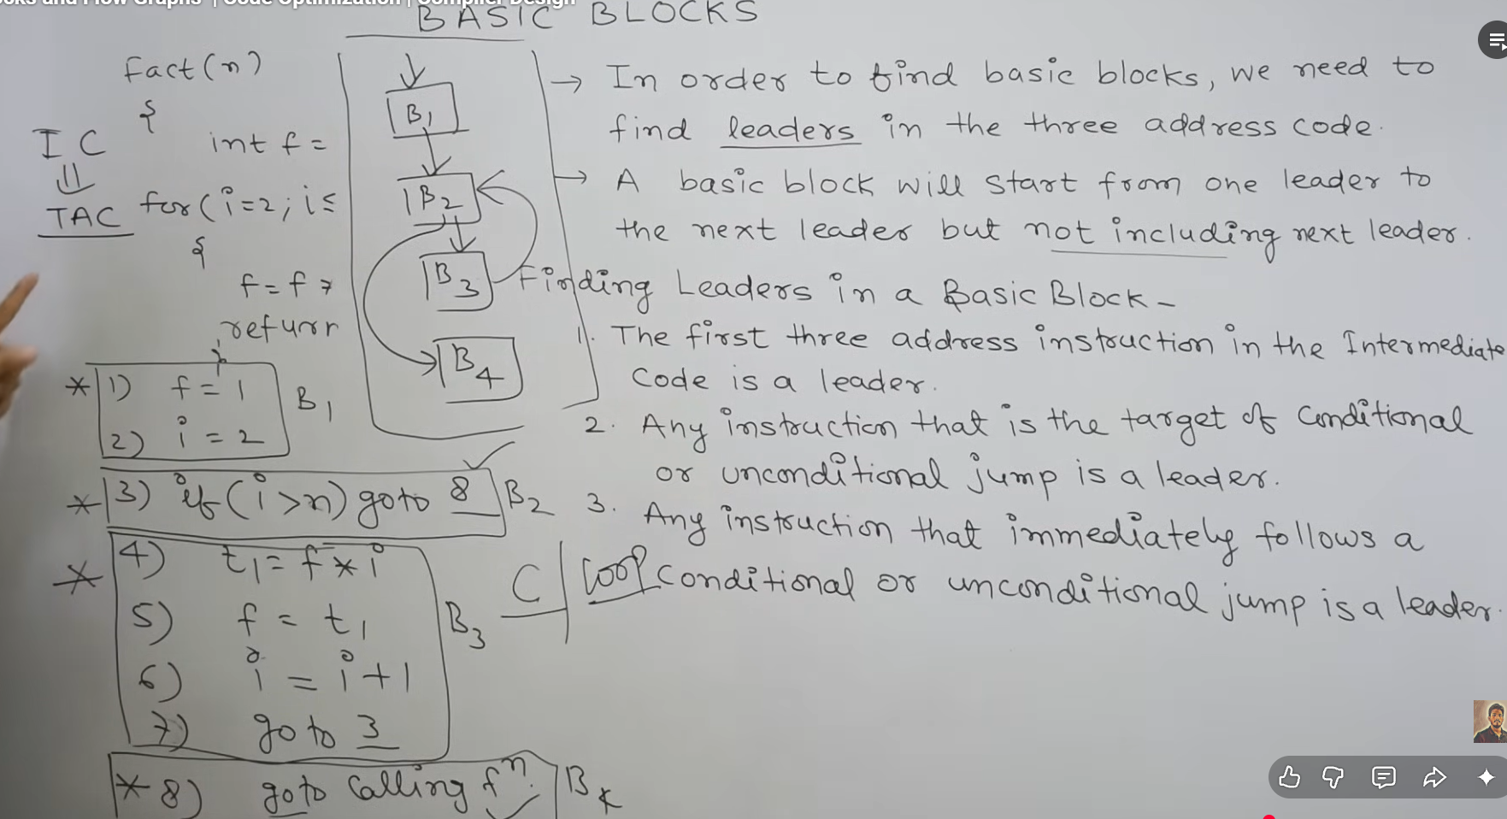

Runtime Environment and Code Generation
🔷 1. Storage Organization
A program’s memory is divided into different regions, each serving a specific purpose.
📌 Memory Layout
|---------------------|
| Code Segment | → Compiled program instructions
|---------------------|
| Static/Data Segment | → Global & static variables
|---------------------|
| Stack | → Function calls, local variables
|---------------------|
| Heap | → Dynamic memory allocation
|---------------------|
🔹 Key Points:
- Stack grows downward, heap grows upward
- Stack is automatic, heap is manual/controlled
- Efficient management is crucial for performance

🔷 2. Activation Trees
An activation tree represents how functions are called during execution.
📌 Example:
main()
├── A()
│ ├── B()
│ └── C()
└── D()
🔹 Explanation:
- Each node = function call
- Parent → calls child
- Shows nested structure of execution
- Used to understand recursion and control flow

🔷 3. Activation Records (Stack Frames)
Each function call creates an activation record stored in the stack.
📌 Structure:
|----------------------|
| Actual Parameters |
| Return Value |
| Return Address |
| Control Link |
| Access Link |
| Local Variables |
| Temporary Variables |
|----------------------|
🔹 Fields:
- Return Address → where control goes back
- Control Link → pointer to caller’s record
- Access Link → used for nested scopes
- Locals/Temps → store variables

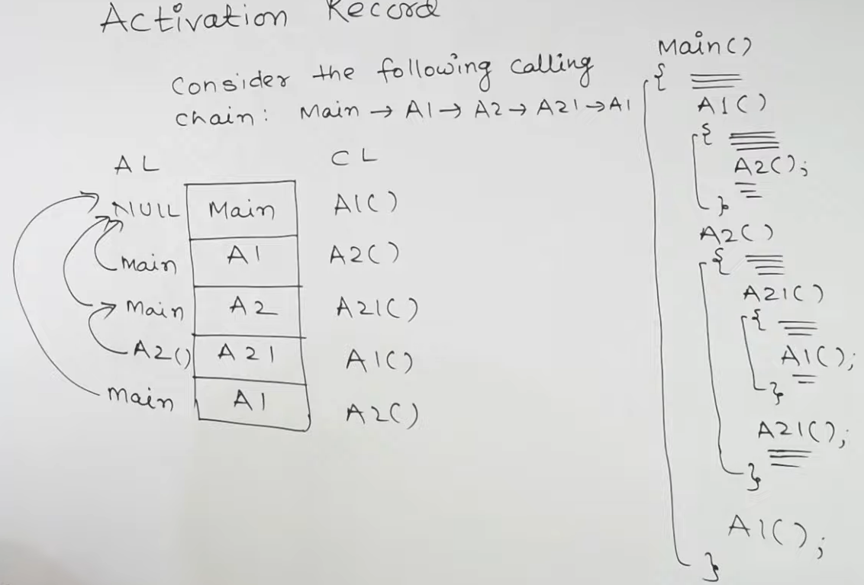

🔷 4. Calling Sequence
Steps executed during a function call:
🔹 Caller Actions:
- Evaluate and push arguments
- Save registers (if needed)
- Transfer control to function
🔹 Callee Actions:
- Create activation record
- Initialize local variables
- Execute function body
🔹 Return Phase:
- Store result
- Restore registers
- Return control to caller

🔷 5. Heap Management
Heap is used for dynamic allocation of memory at runtime.
🔹 Operations:
- malloc() / new → allocate memory
- free() / delete → release memory
🔹 Problems:
- Memory Leak → memory not freed
- Fragmentation → unused gaps in memory
- Dangling Pointer → pointer to freed memory

🔷 6. Garbage Collection (Introduction)
Automatic technique to reclaim unused memory.
🔹 Methods:
- Reference Counting
  - Each object keeps count of references
  - When count = 0 → delete
- Mark and Sweep
  - Mark reachable objects
  - Sweep unmarked ones
🔹 Advantage:
- Reduces programmer effort
- Avoids memory leaks

🔷 7. Code Generation
Final phase of compiler:
- Converts intermediate code → target machine code
🔹 Goals:
- Correctness
- Efficiency
- Optimal use of registers

🔷 8. Issues in Code Generator
🔹 Important Issues:
- Instruction Selection → choose best machine instruction
- Register Allocation → limited registers must be used efficiently
- Evaluation Order → affects performance
- Memory Access → minimize slow memory operations

🔷 9. The Target Language
The output language of compiler:
- Machine code or Assembly
🔹 Considerations:
- Instruction set
- Number of registers
- Addressing modes
- CPU architecture

🔷 10. Basic Blocks
A basic block is a straight-line code sequence.
📌 Properties:
- No branching inside
- Only one entry and one exit
Example:
t1 = a + b
t2 = t1 * c
t3 = t2 - d

🔷 11. Flow Graphs
A flow graph represents control flow using basic blocks.
🔹 Components:
- Nodes → Basic blocks
- Edges → Possible flow of control
Use:
- Helps in optimization
- Identifies loops and branches

🔷 12. Optimization of Basic Blocks
Improves efficiency within a block.
🔹 Techniques:
- Constant Folding
a = 2 + 3 → a = 5
- Common Subexpression Elimination
t1 = a + b
t2 = a + b → reuse t1
- Dead Code Elimination
x = 5 (never used) → remove
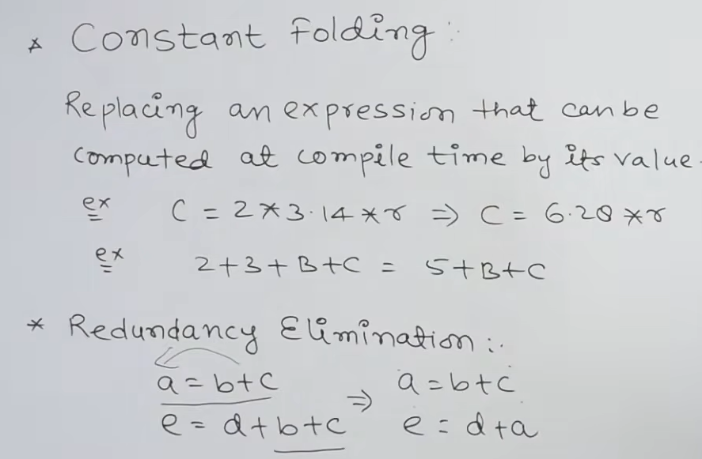
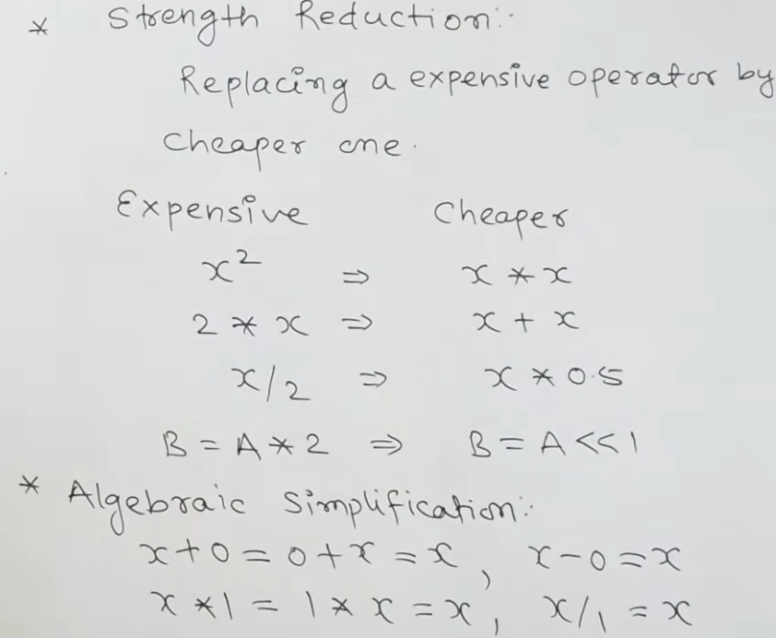

🔷 13. A Simple Code Generator
Converts three-address code (TAC) into machine instructions.
Example:
t1 = a + b
t2 = t1 * c
Generated Code:
MOV R1, a
ADD R1, b
MUL R1, c

🔷 14. Peephole Optimization
Optimizes small sets of instructions (local optimization).
🔹 Techniques:
- Remove redundant instructions
- Replace costly instructions with efficient ones
Example:
MOV R1, a
MOV a, R1
Optimized:
MOV R1, a
